# **COVID-19 Increased Existing Gender Mortality Gaps in High Income More than Middle Income Countries**

Kathleen Beegle, Gabriel Demombynes,

Damien de Walque, Paul Gubbins, Jeremy Veillard[1]

**Abstract**

***Objective***

To analyze how patterns of excess mortality varied by sex and age groups across countries during the COVID-19 pandemic and their association with country income level.

***Methods***

We used World Health Organization excess mortality estimates by sex and age groups for 75 countries in 2020 and 62 countries in 2021, restricting the sample to estimates based on recorded all-cause mortality data. We examined patterns across countries using country-specific Poisson regressions with observations consisting of the number of excess deaths by groups defined by sex and age.

***Findings***

Men die at higher rates in nearly all places and at all ages beyond age 45. In 2020, the pandemic amplified this gender mortality gap for the world, but with variation across countries and by country income level. In high-income countries, rates of excess mortality were much higher for men than women. In contrast, in middle-income countries, the sex ratio of excess mortality was similar to the sex ratio of expected all-cause mortality. The exacerbation of the sex ratio of excess mortality observed in 2020 in high-income countries, however, declined in 2021.

***Conclusion***

The COVID-19 pandemic has killed men at much higher rates than women, as has been well documented, but these gender differences have varied by country income. These differences were the result of some combination of variation in gender patterns of infection rates and infection fatality rates across countries. The gender gap in mortality declined in high-income countries in 2021, likely as a result of the faster rollout of vaccination against COVID-19.

**Introduction**

In all countries around the world, women live longer than men (Dattani and Rodés-Guirao 2023). There is well-established evidence of a gender mortality gap driven by a range of environmental, genetic, and cultural factors (Waldron 1985). The persistence of higher mortality for men than women has been documented with data typically drawn principally from high-income countries (Wu et al. 2021). But these patterns have also been shown in low-income regions of the world (de Walque and Filmer 2013).

Prior to the 1950s, disproportionately higher deaths of male than female infants were the main driver of the longer life expectancy of women, but more recently the elevated mortality of older men has driven the gender gap in life expectancy (Zarullia et al. 2021). The COVID-19 pandemic exacerbated this gap as age-standardized excess death rates were higher for men than women in many countries (Peckham et al. 2020; UN 2022). The sex inequality in mortality grew in many high-income countries due to COVID-19, though in the US, this disparity has been characterized as modest, and mortality from the pandemic has not changed the “fundamental dynamic” of sex-mortality gaps (Nazmul et al. 2021; Danielsen et al. 2022). Likewise, for European countries, the difference in mortality by sex during the COVID-19 pandemic is similar to pre-pandemic patterns (Neilsen et al. 2021). In non-high-income settings, both COVID-19 and excess death age-mortality curves are flatter, only in part due to population structure (Demombynes et al. 2022). This suggests that the extent to which the gender gap in mortality increased likely differs across country income levels. In part due to the lack of data, previous detailed analysis of COVID-19 mortality patterns by age have combined both sexes, neglecting this well-established fact that mortality rates of men are higher than that of women, and that this might vary by country income level.

This study draws on recent data which were not available for earlier studies to examine the extent to which the gender gap in mortality shifted in high- and middle-income countries during the COVID-19 pandemic. Unfortunately, underdeveloped civil registration systems for reporting on male and female deaths limits data availability in low-income countries, a persistent limitation in the study of global population-level mortality patterns.

**Methods**

*Data sources*

We use the “Global excess deaths associated with COVID-19 (modelled estimates)” dataset (19 May 2023 update), produced by WHO’s Technical Advisory Group (TAG) on COVID-19 mortality assessment. This dataset contains estimates of expected all-cause deaths, all-cause deaths (actual or predicted if actual was not available), and excess deaths by age-group and sex for 194 countries for 2020 and 2021. Expected all-cause deaths were forecasted using historic country-level monthly mortality data prior to the pandemic and serve as reference point in the absence of COVID-19. Excess deaths were computed as "the mortality above what would be expected based on the non-crisis mortality rate in the population of interest” by differencing actual/predicted all-cause deaths from expected all-cause deaths (World Health Organisation 2022). These data are not reporting direct COVID-19 deaths only but rather are an estimate of the combination of direct and indirect COVID-19 mortality, as measured by excess deaths.

Lacking actual measures of direct and indirect COVID-19 mortality by sex, we rely on estimates of excess deaths by sex. We check the reliability of these data by comparing sex-mortality ratios from the estimate of excess deaths and those from reported COVID-19 deaths for a subset of countries for which this is available. This ratio of ratios is not always 1. However, there is no clear pattern suggesting that the ratio based on excess deaths is different from that constructed from reported COVID-19 mortality (not shown here but available upon request).

This dataset also contains population counts from the World Population Prospects by country, year, sex and age (UN 2022). The dataset covers 194 countries in 2020 and 194 in 2021. For this analysis, only countries with excess death estimates based on actual all-cause death (not predicted) by sex and age-group are included. This limits the sample to 75 countries in 2020 and 62 countries in 2021. Additionally, we exclude countries with total excess deaths (both sexes combined) below 2,000 in either 2020 or 2021. After applying these two criteria, we have 66 countries in this analysis: 54 in 2020 and 57 in 2021 (Table 1). Lastly, we analyze mortality data only for adults 45 years and older, since excess death rates are extremely low for younger ages.

[TABLE 1]

*Estimating age-mortality patterns*

To characterize the age-mortality patterns drawing on the data from multiple countries, we estimate a model of the age-mortality curve with interactions by sex for each country. The advantages of working with a model are two-fold. First, it produces a slope of the age-mortality curve by sex. Second, it enables the use of predicted values for some estimated quantities which minimize the influence of outliers (discussed above) and, importantly, allows calculation of confidence intervals. The models are estimated separately for 2020 and 2021 by fitting a Poisson regression using deaths as the response variable and population as an offset.

where the age and sex specific number of deaths is for the 10-year age group age to age for sex in country The data points correspond to the group consisting of all ages 85 years and above. To interpret death counts as mortality rates (for the age-sex specific population), an exposure term was introduced as an offset in the model as . is a binary variable where 1 corresponds to men and 0 corresponds to women and is a continuous variable centered at age 65. The coefficients represent the mortality rate for females at the age of 65 years, represents the male-to-female mortality rate ratio at the age of 65, represents the mortality rate ratio for females that differ by 10 years in age, represents the mortality rate ratio for males that differ by 10 years in age. The Poisson regression was fit separately with defined in terms of expected all-cause deaths and with defined in terms of estimated excess deaths for both years. For the latter, when estimated excess deaths were less than 0, they were recoded to 0.

Once the parameters of each country were estimated for expected all-cause and excess deaths for both years, a simulation-based inference was used to gauge uncertainty around predicted sex-ratios of mortality for each country and age group. Using the clarify package for R, 1000 sets of coefficients were simulated from their implied distribution after fitting the model to the data. For each country, these simulated coefficients were used to generate predictions of the mortality rate for males and females for each of the five age groups, by country and year. Taking the ratio of the simulated predicted mortality rates for males and females yielded a distribution of 1,000 predicted sex-ratios of mortality for each age-group that can be used for inference and generating uncertainty bounds. Annex Figure A1 illustrates the results and fit (uncertainty bounds) for one country (Uruguay) of the country and year-specific Poisson model.

**Results**

We start with some brief descriptives of the data we have available. The male-to-female ratio of expected all-cause mortality by age group (starting at age 45) for nearly every country in 2020 is above one (Figure 1). The lone exceptions are amongst the oldest age groups (85+) in Albania and Bosnia and Herzegovina, along with ages 55-74 in Kuwait. In almost all countries, the sex ratio declines starting with the 65-74 age group or earlier. The handful of countries which do not fit this pattern are Bolivia, Egypt, Iran, Kuwait, and Nicaragua. The range on the sex-ratio stays between 1 and 2. In sum, among the countries in this sample, at age 50, men were just over twice as likely to be expected to die from all causes than women, on average, in 2020. The pattern of the sex ratio in mortality by age tends to take an inverse J-shape. These results for all-cause mortality are consistent with evidence noted earlier that pre-dates the COVID-19 pandemic.

The pattern of sex-ratio in excess deaths in 2020 by age show much more variation across countries (Figure 2), and especially as compared to a generally consistent pattern we observe in expected all-cause mortality in Figure 1. The general decline or mild inverse J-shape seen in Figure 1 across all countries is no longer present. Instead, we observe a wide range of differing patterns, in some cases a J shape than an inverse J shape (such as in Iran and South Africa). Second, the scale itself is much wider. Whereas before the ratio stayed between 1 and 2, we now have some extremely high ratios, and a handful of values below 1 (and in a few cases, below 0). For example, the excess mortality sex-ratio for men and women in Germany ages 65-74 jumps to 30, whereas it is negative for German adults 45-54 years. For both 45-54 and 55-64 year olds, the sex-ratio is negative in the Dominican Republic, but jumps to over 18 for 75-84 and 85+ age groups. Part of this reflects the sensitivity of ratios for small base value comparisons. For example, in Hungary, the estimate of excess deaths for women 45-54 years old is -3.3 (effectively 0), whereas for men it is 126, resulting in a ratio of -37. Similarly, in the Dominican Republic, there were 14 estimated excess deaths for women 85 and older, compared to 256 for men, resulting in a ratio of 19.

Drawing on our Poisson estimates, Table 2 reports the estimates of four measures: female mortality at age 65, male-female mortality ratio at age 65, and the age slope of female and male morality for an additional 10 years of age. These are estimated for 2020 expected all-cause mortality, 2020 excess mortality, and 2021 excess mortality. Table 3 shows the population-weighted results overall and for each of three country-income tercile groupings (population weighted).

In 2020, the average ratio of male-to-female mortality is higher for excess deaths (2.21) than for expected all-cause deaths (1.69) (2020 columns 2 and row 1 of Table 3), and this is also the case for each of the three country-income tercile groups (Table 3). COVID-19 amplified the gender mortality gap, at least at the age point of 65, in 2020. By 2021, the sex-ratio of excess deaths has fallen (to 1.84) but is still above the sex ratio for expected all-cause mortality in 2020 (1.69). However, across income terciles there is variation. In the lowest income grouping, the excess mortality sex ratio in 2021 is slightly lower than for expected all-cause 2020, whereas in the high-income countries, it remains well above (2.23 in 2021 and 2.3 in 2020 compared to 1.71 for expected all cause deaths in 2020).

The slope of the curve of mortality by age (the change in mortality associated with an additional 10 years of age) goes up sharply from expected all-cause to excess deaths for both women (from 2.95 to 3.46) and for men (2.49 to 2.89) in 2020. And this slope is greater for women than men, as is expected given the higher mortality rates at younger ages for men in excess deaths in 2020. (The sex-ratio of mortality at age 65 is necessarily linked to the age-slope of mortality for women and men.) These patterns in excess mortality patterns shift remarkably by 2021. By 2021, the age slope of mortality shows much less of a gap; it is relatively similar for women (2.40) and for men (2.33).

Notably, this pattern in excess deaths age-slopes differs across our country-income terciles in 2020. The age slope of mortality is highest for women in high-income countries for 2020 (both expected all-cause deaths and excess deaths), but it falls dramatically by 2021 when it is slightly lower than that of men (2.40 for women and 2.49 for men). On the other hand, in countries in the first and second terciles, in 2021, the age slope in mortality remains slightly higher for women.

A last point of note is that female excess mortality at age 65 increases dramatically (almost doubles) for countries in the first and second terciles from 2020 and 2021 (from 447 to 832 for tercile 1 countries, and from 439 to 824 for tercile 2 countries), whereas it increases much more modestly from 2020 to 2021 for the high-income countries in tercile 3 (from 131 to 149). Another way to view the patterns by age, sex, and country, is to examine the mortality sex-ratio (M/F) for countries by tercile of GNI per capita, as shown in Figure 3. (See also Annex Table A1.) These figures show that the widening of the gender mortality gap driven by COVID-19 in 2020 was limited to higher income countries and principally among adults ages 45-54 and 55-65. Figure 4 displays the same data with individual country points. Annex Figure A2 shows the same figure with the subset of countries held constant across years.

**Discussion**

This paper, using a global dataset covering a wide swath of middle- and high-income countries, confirms previous findings, based on more limited data, that for all age groups above age 45 and in all countries with few exceptions, men die at higher rates than women. It also identifies global variation in patterns of COVID-19 mortality by age and sex. The findings complement the finding from Demombynes et al. (2022) that the age curve of excess deaths in 2020 was flatter for middle-income countries and steeper in wealthier countries. The findings in this paper demonstrate that this difference is principally driven by the mortality patterns of men, resulting in COVID-19 amplifying the gender mortality gap in 2020 more in richer countries as compared to less-wealthy countries.

An important limitation of this study is that because it excludes excess mortality estimates not based on actual observed mortality, it does not include any low-income country.

Still, these findings point to the need to consider public policies during public health emergencies that offer more targeted protection for men over 45 with co-morbidities, for example those working in jobs exposing them to a higher risk of infections.

The patterns found will hopefully inspire future country-level research using cause-of-death data to get a fuller understanding of relevant drivers of age-gender mortality patterns. It is worthwhile to explore structural socioeconomic conditions that vary with country income and sex, which would also interact with both infection exposure and fatality rates. This would include, for example, the structure of jobs and employment patterns (well documented to vary by country income and sex), especially the extent of remote work opportunities which may reduce exposure to infections during a pandemic. Another example is the extent of residency in long-term care facilities. Older persons, especially older women, have higher likelihoods of residing in nursing homes in wealthier countries. When these facilities are of poor quality and safety they result in greater exposure (Webster 2021). A third area could be the profile of co-morbidities pre-existing in the population. For example, women are relatively more obese than men in low and middle income economies but not in high-income countries (Ameye and Swinnen 2019).

Lastly, the analysis in this paper is also a reminder of the value of demographic data and the value of efforts by country governments and international organizations to promote and standardize vital statistics data.

**Acknowledgements**

**Funding**

This work was supported by the World Bank Research Support Budget.

**Competing Interests**

**Table 1. Sample of countries in analysis**

|  |  |  |  |
| --- | --- | --- | --- |
| **Income Tercile** | **N** | **GNI per capita (PPP) range** | **Countries** |
| 1 | 22 | 5,000 - 15,530 | Albania, Azerbaijan, Bolivia (Plurinational State of), Brazil, Colombia, Cuba, Ecuador, Egypt, Georgia, Guatemala, Iran (Islamic Republic of), Iraq, Kyrgyzstan, Republic of Moldova, Mongolia, Nicaragua, Peru, Paraguay, Tunisia, Ukraine, Uzbekistan, South Africa |
| 2 | 22 | 16,090 - 33,730 | Argentina, Bulgaria, Bosnia and Herzegovina, Chile, Costa Rica, Dominican Republic, Greece, Croatia, Hungary, Kazakhstan, Latvia, Mexico, Oman, Panama, Poland, Romania, Russian Federation, Serbia, Slovakia, Thailand, Uruguay, Malaysia |
| 3 | 22 | 36,330 - 70,150 | Australia, Austria, Belgium, Canada, Switzerland, Czechia, Germany, Spain, Estonia, Finland, France, The United Kingdom, Israel, Italy, Japan, Republic of Korea, Kuwait, Lithuania, Netherlands, Portugal, Sweden, USA |
| Note: Country sample used from the WHO Global Excess Deaths dataset. | | | |

**Figure 1**

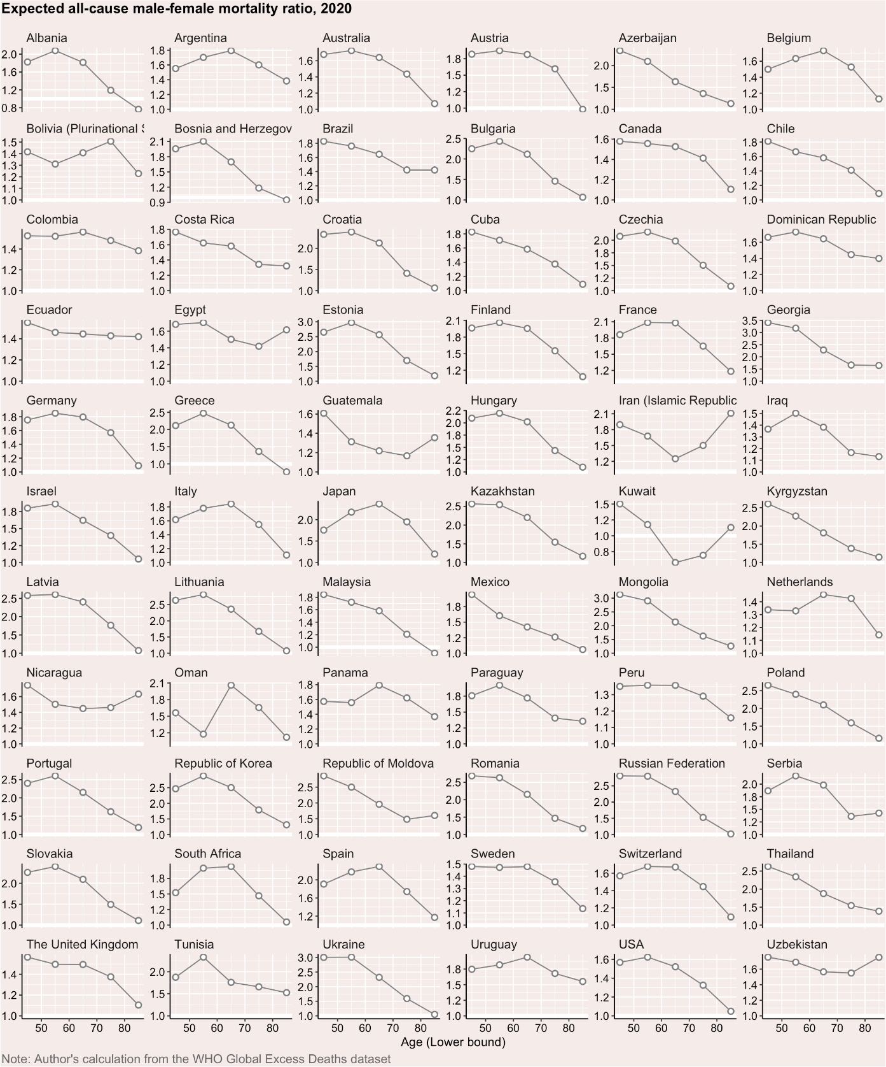

**Figure 2**

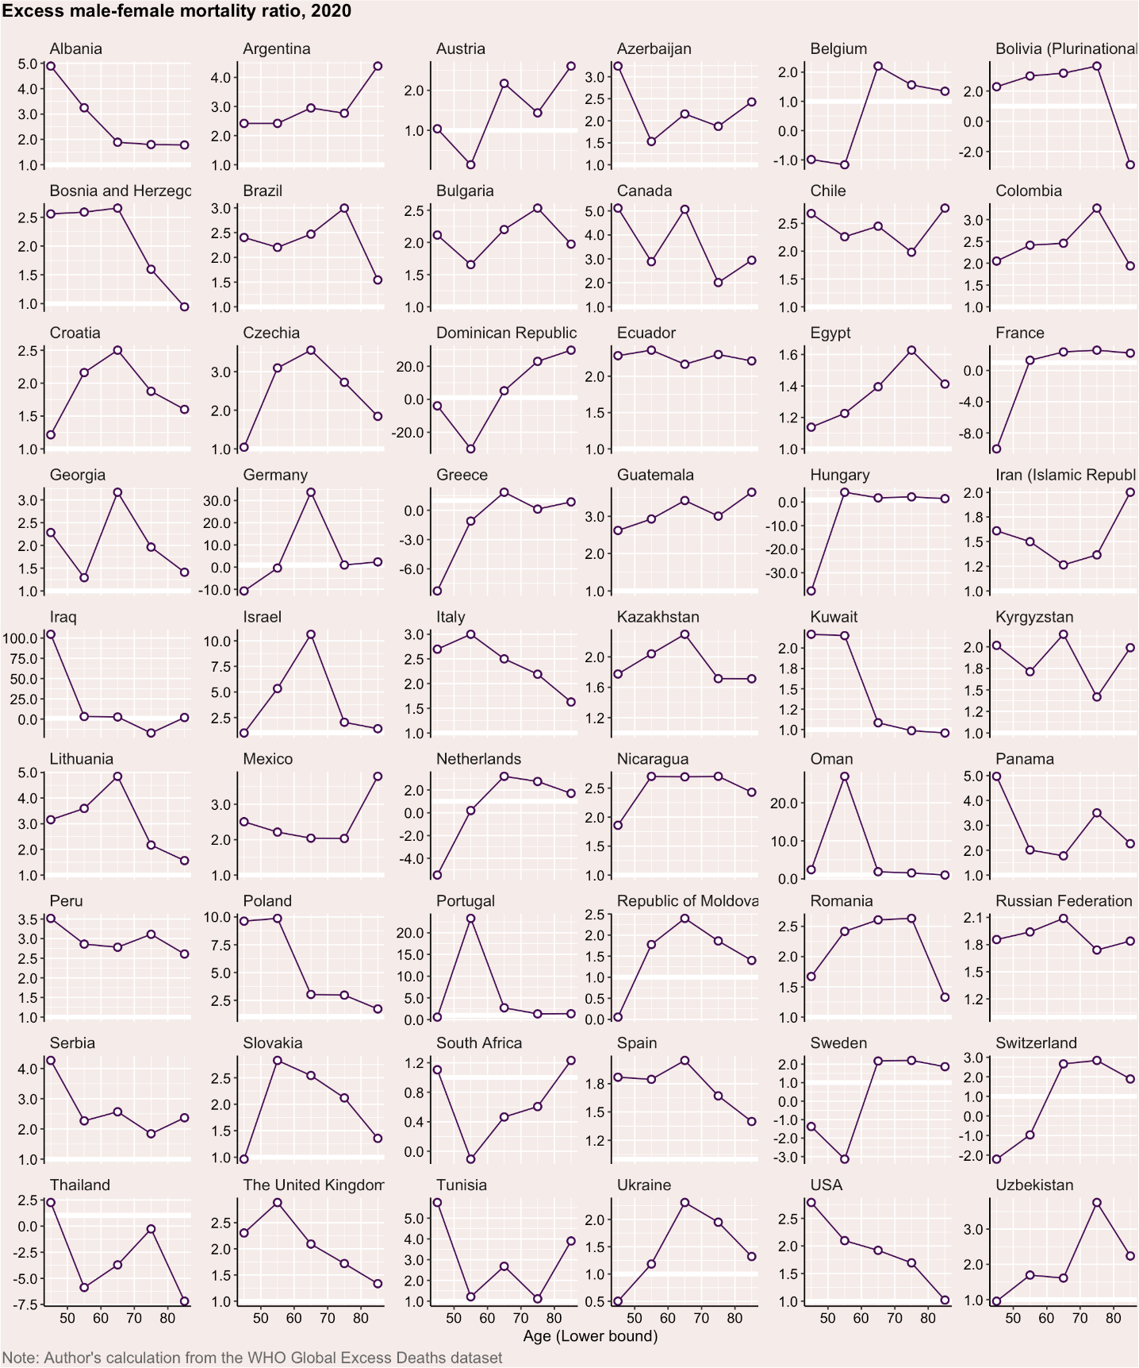

**Table 2. Country regression estimates describing how mortality rates vary by age and sex**

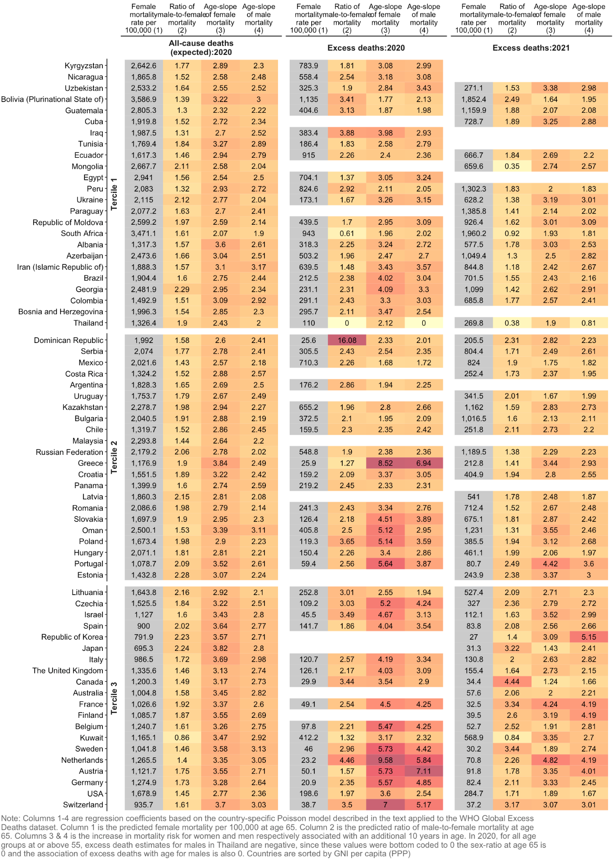

**Table 3: Results from country regression estimates describing how mortality rates vary by age and sex, by income tercile groupings** 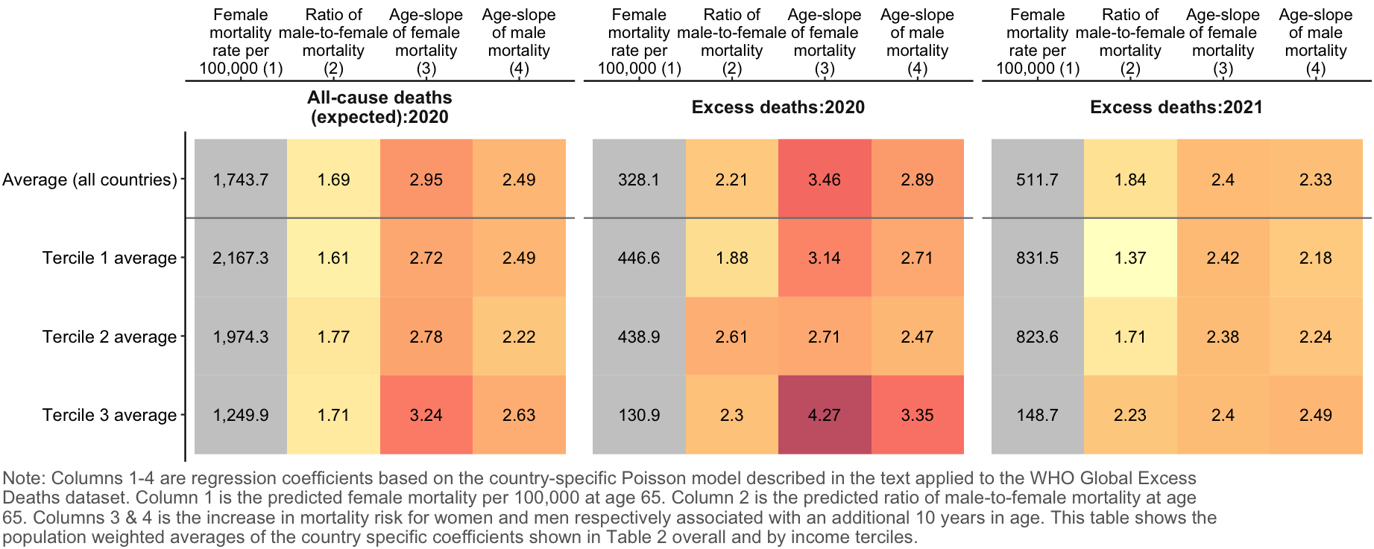

**Figure 3. Predicted mortality sex ratio by age group and country income tercile**

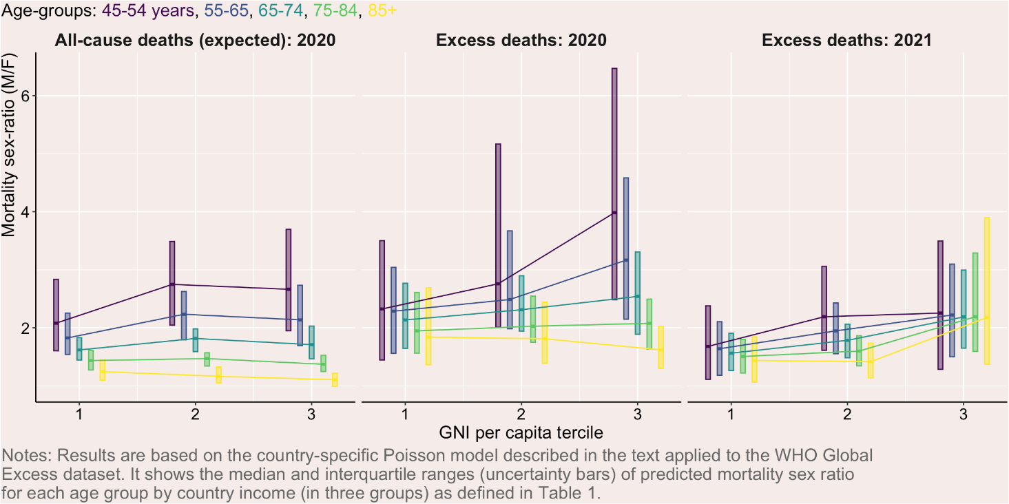

**Figure 4. Predicted mortality sex ratio by age group and country GNI per capita**

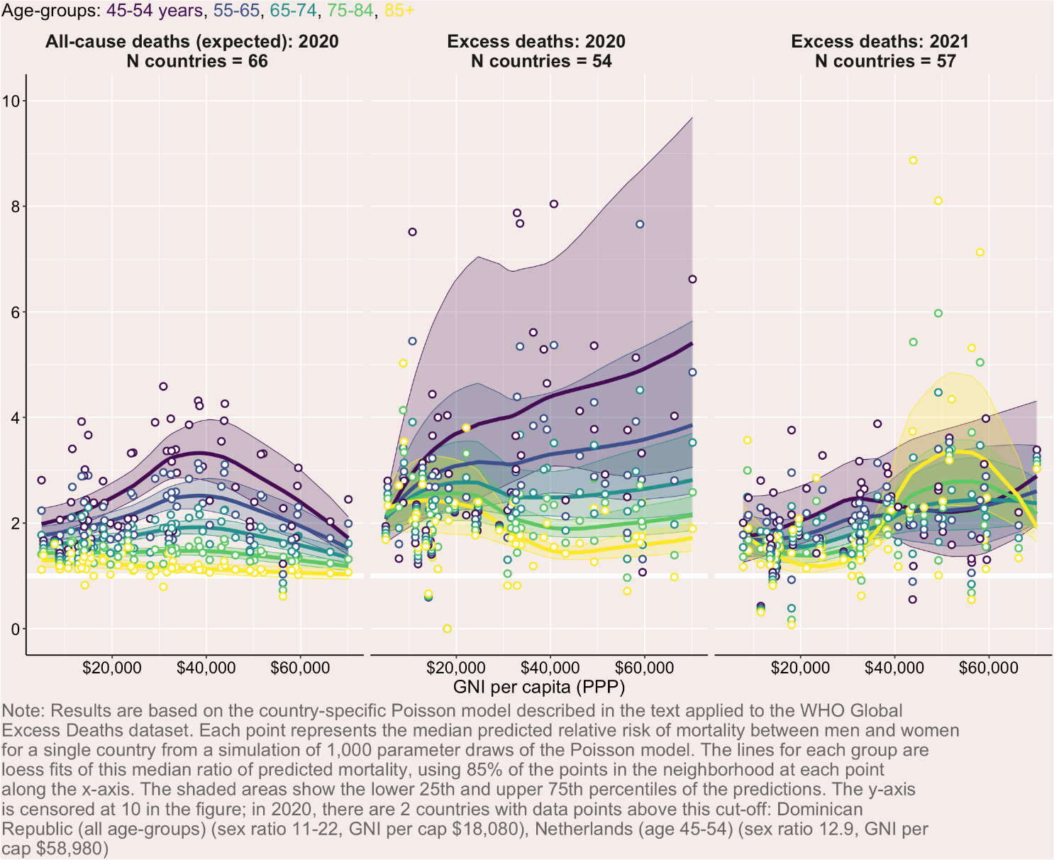

**References**

Ameye, Hannah, and Johan Swinnen. 2019. “Obesity, income and gender: The changing global relationship.” *Global Food Security* 23: 267-281.

Danielsen, Ann Caroline, Katharine MN Lee, Marion Boulicault, Tamara Rushovich, Annika Gompers, Amelia Tarrant, Meredith Reiches, Heather Shattuck-Heidorn, Luke W. Miratrix, and Sarah S. Richardson. 2022. “Sex disparities in COVID-19 outcomes in the United States: Quantifying and contextualizing variation.” *Social Science and Medicine* 294.

Demombynes, Gabriel, Damien de Walque, Paul Gubbins, Piedad Urdinola, Jeremy Veillard. 2022. “Are COVID-19 age-mortality curves for 2020 flatter in developing countries? Evidence from a cross-sectional observational study of population-level official death counts and excess deaths estimates.” BMJ Open 12(11).

Dattani, Saloni and Lucas Rodés-Guirao. 2023. “Why do women live longer than men?” Published online at OurWorldInData.org. Retrieved from: 'https://ourworldindata.org/why-do-women-live-longer-than-men' [Online Resource]

De Walque, Damien and Deon Filmer. 2013. “Trends and Socioeconomic Gradients in Adult Mortality around the Developing World.” Population and Development Review 39(1): 1-29.

Ly, Tran Duc Anh, Didier Zanini, Vincent Laforge, Sylvie Arlotto, Stephanie Gentile, Helene Mendizabal, Michael Finaud, David Morel, Olivier Quenette, Priscilla Malfuson-Clot-Faybesse, Alain Midejean, Phuc Le-Dinh, Gérard Daher, Berengere Labarriere, Anne-Marie Morel-Roux, Alain Coquet, Patrick Augier, Philippe Parola, Eric Chabriere, Didier Raoult, and Philippe Gautret. 2020. “Pattern of SARS-CoV-2 infection among dependant elderly residents living in long-term care facilities in Marseille, France.” International Journal of Antimicrobial Agents 56(6).

Nielsen, Jens, Sarah K. Nørgaard, Giampaolo Lanzieri, Lasse S. Vestergaard, and Kaare Moelbak. 2021. “Sex‑differences in COVID‑19 associated excess mortality is not exceptional for the COVID‑19 pandemic.” Scientific Reports.

Peckham, Hannah, Nina M. de Gruijter, Charles Raine, Anna Radziszewska, Coziana Ciurtin, Lucy R. Wedderburn, Elizabeth C. Rosser, Kate Webb, and Claire T. Deakin. 2020. “Male sex identified by global COVID-19 meta-analysis as a risk factor for death and ITU admission.” Nature Communications.

United Nations. 2022. World Population Prospects 2022: Summary of Results.

Waldron, Ingrid. 1985. "What do we know about causes of sex differences in mortality? A review of the Literature." *Population Bulletin of the United Nations* 18: 59-76.

Webster, Paul. 2021. “COVID-19 highlights Canada’s care home crisis.” Lancet 397.

World Health Organisation. 2022. “Methods for estimating the excess mortality associated with the COVID-19 pandemic.” (March 29, 2022)

Wu, Yu-Tzu, Albert Sanchez Niubo, Christina Daskalopoulou, Dario Moreno-Agostino, Denes Stefler, Martin Bobak, Sian Oram, Martin Prince, and Matthew Prina. 2021. “Sex differences in mortality: results from a population-based study of 12 longitudinal cohorts.” *Canadian Medical Association Journal*: E361-70.

Zarullia, Virginia Ily, Kashnitskya, and James W. Vaupela. 2021. “Death rates at specific life stages mold the sex gap in life expectancy.” *PNAS* 118(20).

**Annex**

**Table A1. Predicted mortality sex ratio by age group and country income tercile**

|  |  |  |  |  |
| --- | --- | --- | --- | --- |
| **Mortality type and year** | **Age (Lower bound)** | **Tercile 1 (Poorest)** | **Tercile 2** | **Tercile 3 (Richest)** |
| All-cause deaths (expected): 2020 | 45 | 2.08 (1.6-2.84) | 2.75 (2.05-3.49) | 2.66 (1.95-3.7) |
| 55 | 1.83 (1.54-2.25) | 2.23 (1.79-2.63) | 2.14 (1.69-2.73) |
| 65 | 1.62 (1.45-1.83) | 1.82 (1.59-1.98) | 1.71 (1.47-2.03) |
| 75 | 1.44 (1.27-1.61) | 1.47 (1.34-1.57) | 1.37 (1.25-1.53) |
| 85 | 1.25 (1.1-1.45) | 1.17 (1.05-1.33) | 1.11 (1-1.22) |
| Excess deaths: 2020 | 45 | 2.33 (1.45-3.5) | 2.76 (2.01-5.17) | 3.98 (2.49-6.47) |
| 55 | 2.29 (1.56-3.04) | 2.49 (1.99-3.67) | 3.17 (2.15-4.58) |
| 65 | 2.14 (1.65-2.77) | 2.31 (1.94-2.9) | 2.54 (1.89-3.31) |
| 75 | 1.95 (1.56-2.61) | 2.03 (1.75-2.55) | 2.08 (1.64-2.49) |
| 85 | 1.84 (1.37-2.69) | 1.81 (1.39-2.44) | 1.62 (1.3-2.02) |
| Excess deaths: 2021 | 45 | 1.68 (1.11-2.38) | 2.19 (1.61-3.06) | 2.25 (1.29-3.5) |
| 55 | 1.64 (1.19-2.11) | 1.95 (1.56-2.43) | 2.22 (1.5-3.1) |
| 65 | 1.56 (1.27-1.91) | 1.79 (1.48-2.06) | 2.19 (1.65-2.99) |
| 75 | 1.51 (1.22-1.8) | 1.6 (1.35-1.87) | 2.19 (1.6-3.29) |
| 85 | 1.44 (1.06-1.84) | 1.42 (1.14-1.74) | 2.18 (1.37-3.9) |
| Note: This table shows the median and interquartile ranges in parentheses of predicted mortality sex ratio for each age group, by country income tercile grouping as shown in Figure 3. | | | | |

**Figure A1. Uruguay example of country-specific Poisson model fit**

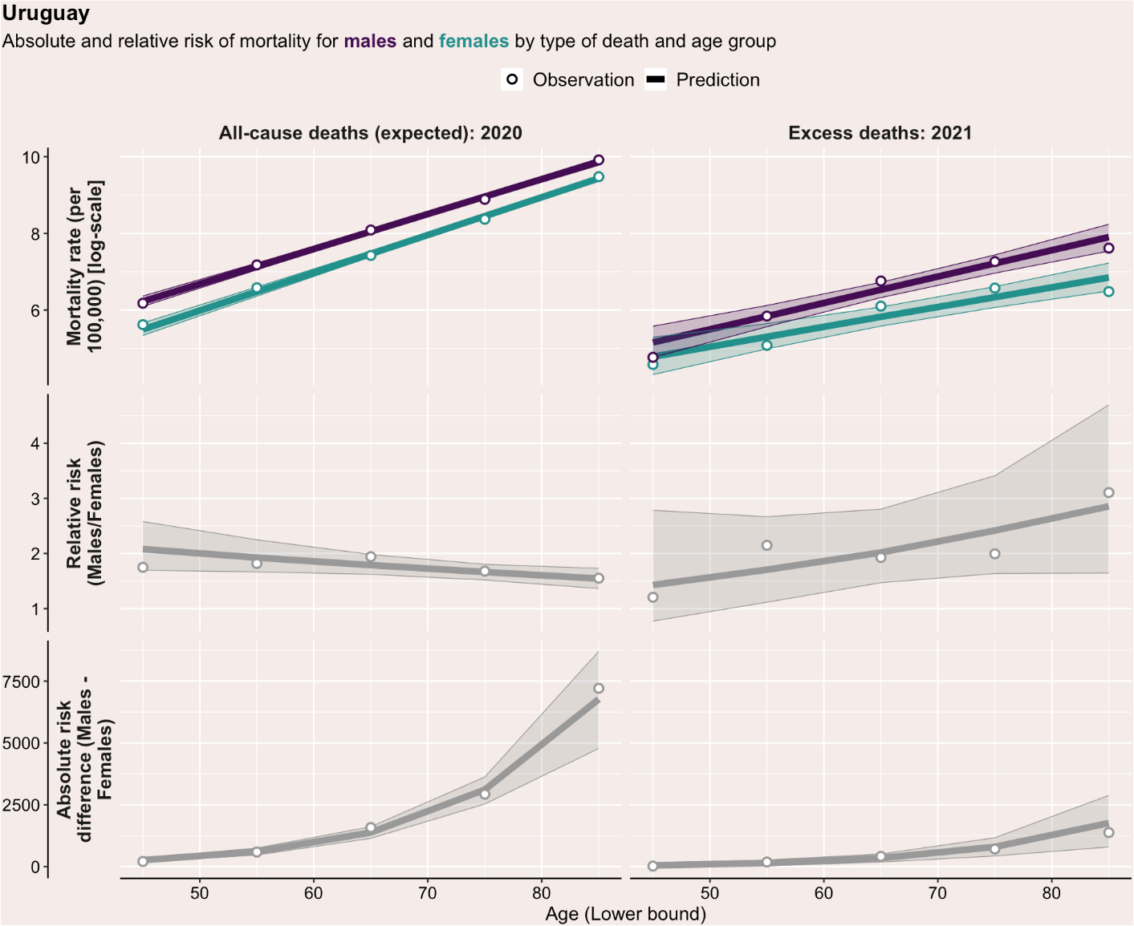

Note: The bands above and below the median estimate represent the 5th and 95th percentile of the simulated distribution of predicted sex-ratios at a given age, describe in detail in the text.

**Figure A2. Country income patterns in predicted mortality sex ratio, constant country comparison**

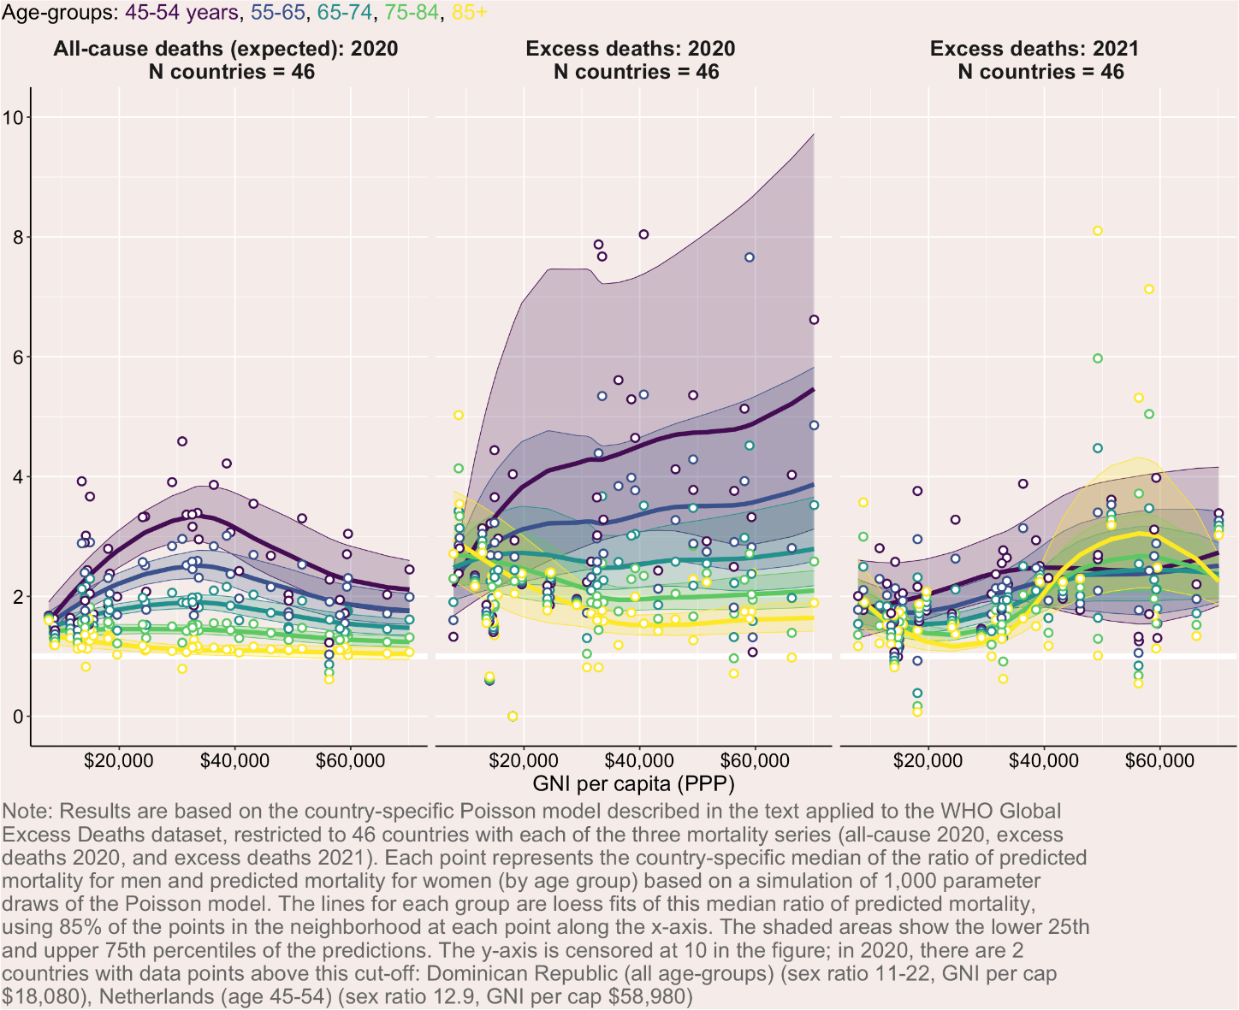

1. Beegle, Demombynes, de Walque, and Veillard are staff of the World Bank. Gubbins is an independent consultant. The findings, interpretations, and conclusions expressed in this paper are entirely those of the authors. They do not necessarily represent the views of the World Bank and its affiliated organizations, or those of the Executive Directors of the World Bank or the governments they represent.